**Traffic Signs Recognition**

Submitted in partial fulfillment of the requirements for the award of degree of:

**BACHELOR OF ENGINEERING**

**IN**

**COMPUTER SCIENCE & ENGINEERING**



**Submitted to: Submitted By:**

Ass. pro shanky goel **Student Group**

**NAME and UID:**

Aditya(18bcs6656)

Shivam(18bcs3054)

Kanishka(18bcs6634)

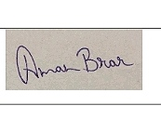

**Mentor Signature( Mrs. Amandeep kaur)**

**DEPARTMENT OF COMPUTER SCIENCE & ENGINEERING**

**Chandigarh University, Gharuan**

**Introduction:**

You must have heard about the self-driving cars in which the passenger can fully depend on the car for traveling. But to achieve level 5 autonomous, it is necessary for vehicles to understand and follow all traffic rules.

In the world of Artificial Intelligence and advancement in technologies, many researchers and big companies like Tesla, Uber, Google, Mercedes-Benz, Toyota, Ford, Audi, etc are working on autonomous vehicles and self-driving cars. So, for achieving accuracy in this technology, the vehicles should be able to interpret traffic signs and make decisions accordingly.

**Feasibility study:**

### What is Traffic Signs Recognition? There are several different types of traffic signs like speed limits, no entry, traffic signals, turn left or right, children crossing, no passing of heavy vehicles, etc. Traffic signs classification is the process of identifying which class a traffic sign belongs to.

In this Python project example, we will build a deep neural network model that can classify traffic signs present in the image into different categories. With this model, we are able to read and understand traffic signs which are a very important task for all autonomous vehicles.

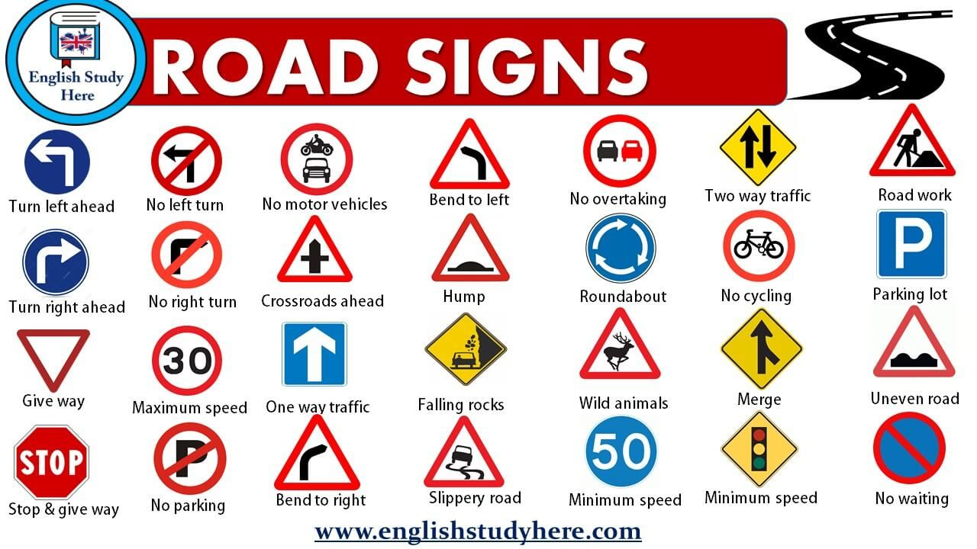

**Planning of work:**

For this project, we are using the public dataset available at Kaggle.

The dataset contains more than 50,000 images of different traffic signs. It is further classified into 43 different classes. The dataset is quite varying, some of the classes have many images while some classes have few images. The size of the dataset is around 300 MB. The dataset has a train folder which contains images inside each class and a test folder which we will use for testing our model.

Our approach to building this traffic sign classification model is discussed in four steps:

* Explore the dataset
* Build a CNN model
* Train and validate the model
* Test the model with test dataset

**Team member wise distribution of work:**

1. The project work is divided based on the actual task for the designing, implementation, test and optimization. As it has been primary planned.
2. Data statistics and relative materials is collected and shared through Drop-box.
3. The individual implementation of functions was assigned to different students, but the student was not only caring his own part, but also considering the whole program.
4. According to the requirements that had been identified, collected all there sources and useful references from the channel, together with the programming skills and experiences, the design items were pointed out.
5. We started Implement each individual sign item based on the planning, structure and references.

**Innovation in project:**

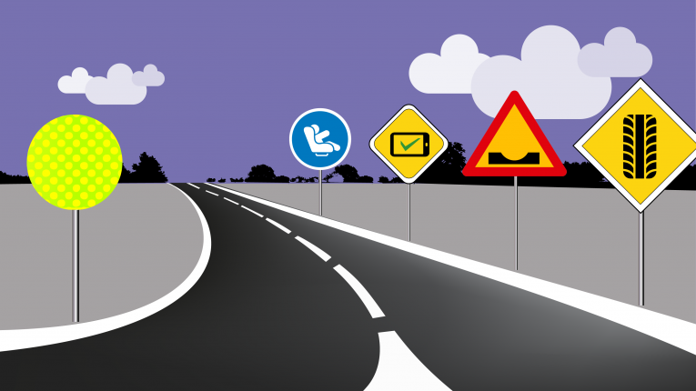

In this project, we will build a deep neural network model that can order traffic signs present in the picture into various classifications. With the help of this model, we are able to read and understand/comprehend the traffic signs which are a very important task for all autonomous/independent vehicles.

1. This project requires some knowledge on topics like Python, Keras and CNN and some python library Matplotlib, Scikit-learn, Pandas, PIL and image classification.
2. **Python-**For programming purposes, we are going to utilize Python as the Programming language. Python is easy to learn and work on with the language. It is an elevated level, broadly useful programming and profoundly intruded on language.
3. **CNN-**The convolutional neural system is a class of profound neural systems, most generally applied to break down visual symbolism. CNN is a class of significant neural frameworks, most usually applied to separate visual imagery.ep neural frameworks, most routinely applied to explore visual imagery.
4. **Build CNN-** some fundamental steps of the task contains-

* Convolution
* Pooling
* Flattening

1. **Keras-** Keras is a significant level neural systems API, equipped for running over Tensorflow, Microsoft Cognitive Toolkit, R, Theano, or PlaidML and CNTK. It empowers quick experimentation through an elevated level, easy to use, particular and extensible API. Keras can likewise be run on both CPU and GPU.
2. Point to be noted, “Programmers can explore different avenues regarding the programming language as indicated by their solace level and information" and can change the previously mentioned language as per them.

**Software Requirement:**

-Programming language -  Python

-Operating System - any os like a window, ubuntu.

**Python (version 3.8)** - Python is a programming language that lets you work more quickly and integrate your systems more effectively. It includes libraries necessary for developing a machine learning project.

**PyCharm** - PyCharm is an integrated development environment (IDE) used in computer programming, specifically for the Python Language. It is developed by the Czech company JetBrains. It provides code analysis, a graphic debugger, an integrated unit tester, integration with version control systems (VCSes). It is cross-platform with Windows, Linux, and macOS.

**Microsoft Word**- Word is a word processor published by Microsoft. It is one of the office productivity applications included in the Microsoft Office suite. Microsoft Word allows you to create professional-quality documents, reports, letters, and resumes. Unlike a plain text editor, Microsoft Word has features including spell check, grammar check, text and font formatting, and more. In this project, it will be used to do most of the Documentation Work.

